Pauline Wijesinghe, the Sri Lanka Women’s Swimming Project’s most senior swimming teacher, organized a 10th Post-Tsunami Anniversary celebration to honor the Project’s founder, Christina Fonfe’, seen below.

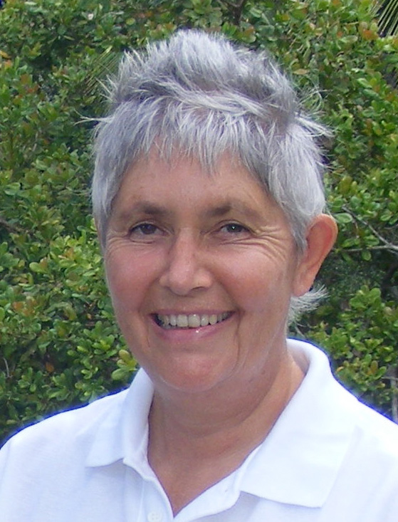
Chris Fonfe´
It seems hardly possible that a decade has gone by since Christina Fonfe´ was totally moved by television images of the 2004 Tsunami to ‘do something’ and leave her family of 36 years as a ‘military wife’ and her prestigious swim school in England behind in order to give relief to tsunami-surviving parents in refugee camps by teaching their children to swim. It was there that she discovered the mothers bringing the children could not swim either and that 80% of those who drowned in the tsunami were women and children. And so the Women’s Swimming Project in Sri Lanka was born.

Christina’s Free Lessons program, pioneering “Float-and-Breathe First”, has been supported by Marlow Rotary Club since 2007, whose donations have helped to directly fund the stipendiary salaries of the Project’s local teachers. Initial one-to-one instruction, with the teacher in the water to completely master back-floating, follows the Total Immersion® method of teaching effortless, streamlined gliding and breathing synchronized with stroke. Very early on, Christina extended the program to include teenage girls on the grounds that they are tomorrow’s mothers. Those with the most aptitude are trained, first as student swimming teachers and then as internationally-qualified swimming teachers to assist in the Project, while other Project graduates have carved out new careers abroad to support themselves by teaching swimming in Australia and in Abu Dhabi.

The Project is an enthusiastic supporter of the International World Drowning Prevention effort to re-define ‘Can Swim’ in terms of aquatic competence and uniquely uses a pilot standard of a jump into deep water, a 10 minute float, a 100 metre swim without touching pool sides or floor and an unaided climb out over a 30 cm ledge to gain a “Can Swim Safely in a Swimming Pool” certificate, locally known as the icanswimcanyou certificate. The UK Swimming Teachers Association www.sta.co.uk , in turn, supports the Project by waiving swimming teacher course fees. Locally, the Project is sponsored by the Sri Lanka Aquatic Sports Union. Thanks also to Total Immersion® founder, Terry Laughlin, the bulk of our training material comes from www.totalimmersion.net. And so, with all this help, the Project has achieved ten uninterrupted years of teaching four and a half thousand women and teenage girls to swim.

The celebration took place in the village of Ahangama, around a portable 12 metre 60,0000 liter fabric pool donated by the British High Commission in Colombo, which enables women and girls to learn to swim in complete privacy in a safe, clean and secure environment. The afternoon began with street procession of past and present swimmers and teachers behind their ‘We Can Swim! Can You?’ banner, led by a troupe of traditionally dressed Kandyan dancers and drummers.

After appropriate speeches, Christina was invited to cut a celebratory swimming pool cake complete with Total Immersion® swimmers. As Chris cannot eat wheat-based food, she was then presented with her own personal, gluten-free cake decorated with a red rose, in the center of which stood the swimmers’ gift: a golden ring set with a tear-drop sapphire. The ring represents the circle of swimmers she has taught and the sapphire represents Sri Lanka and its surrounding deep blue waters, in which the women can, of course, now swim in.

The day ended with the women and teenage girls having fun in the new swimming pool and showing off their ten-minute floating and other survival swimming skills made possible by Christina’s Project. Highlight of the day was to battle against the installed Endless Pools® ‘Fastlane’ swim-current generator, to show their unbelieving and envious husbands and sons that they truly “Can Swim”.

The Project is a registered UK Charity No 1129236. Donations can be made directly to the Project through British Telcom’s no-fee donation channel www.mydonate@bt.com. Christina is also always pleased to hear from fellow drowning prevention enthusiasts at her email: icanswimcanyou@mac.com

Supporting Images

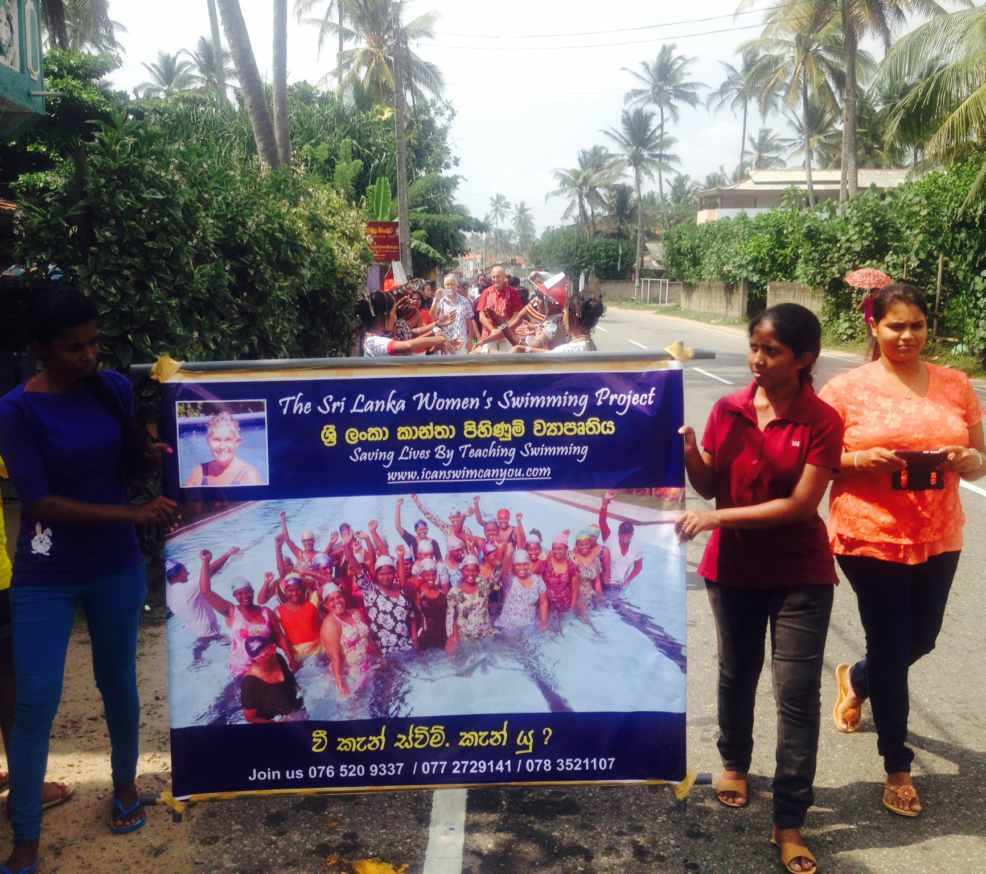
Image 1. Women’s Swimming Project swimmers and STA teachers proudly take the Project Banner on a street procession to proclaim that they “Can swim”

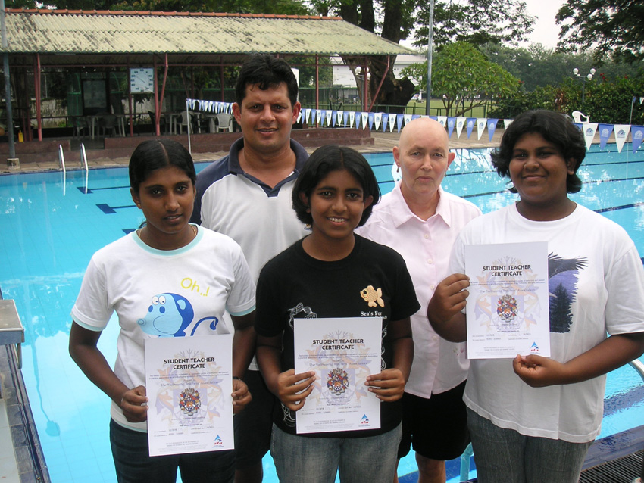
Image 2. Not even chemo-therapy for cancer in 2006-7 could interrupt Christina’s drive to teach swimming in Sri Lanka, seen here with the De Silva sisters, Sanduni (now in Dubai) and Olympian Julian Bolling, for presentation of their first Teaching Certificates.

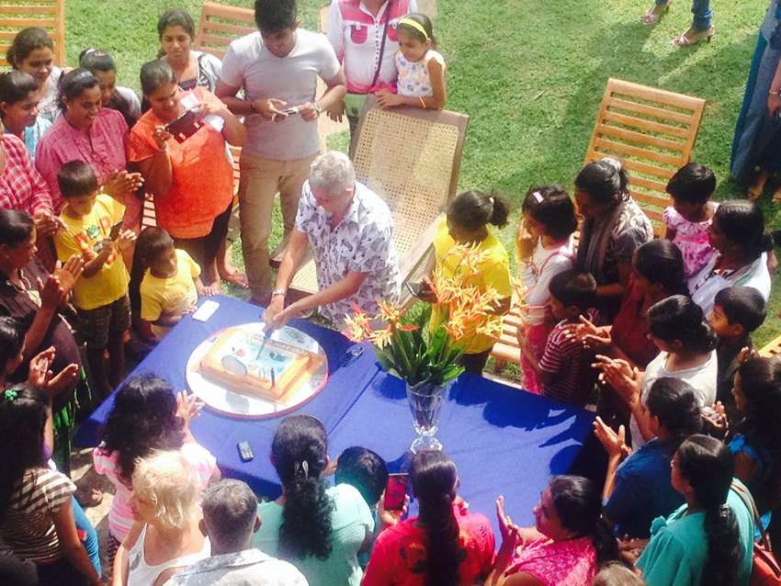
Image 3. Project swimmers gather around Christina as she makes the first cut into the celebratory ‘Swimming Pool’ cake complete with fish-like TI swimmers.

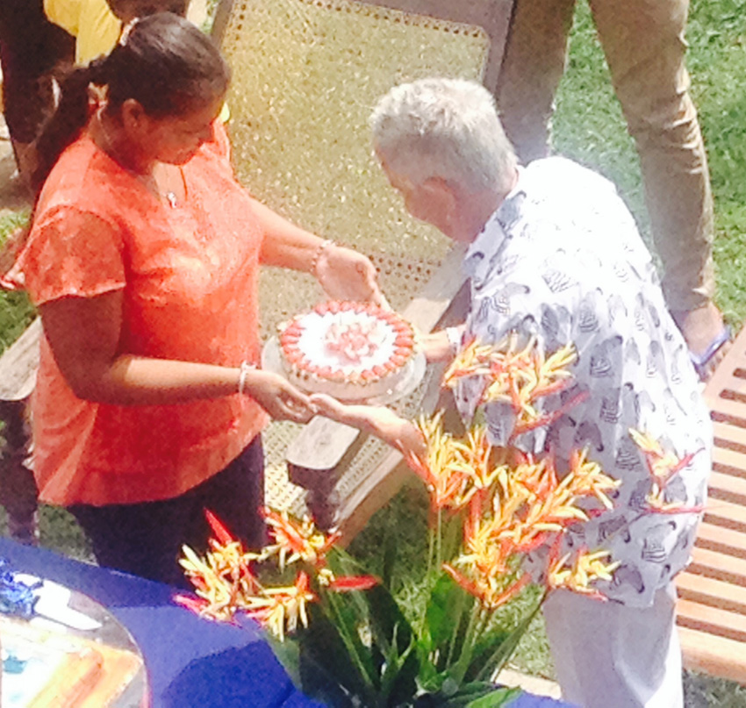
Image 4. Christina is presented with a golden sapphire ring atop a personalized gluten-free cake in recognition of her decade of devotion to drowning prevention and teaching swimming in Sri Lanka

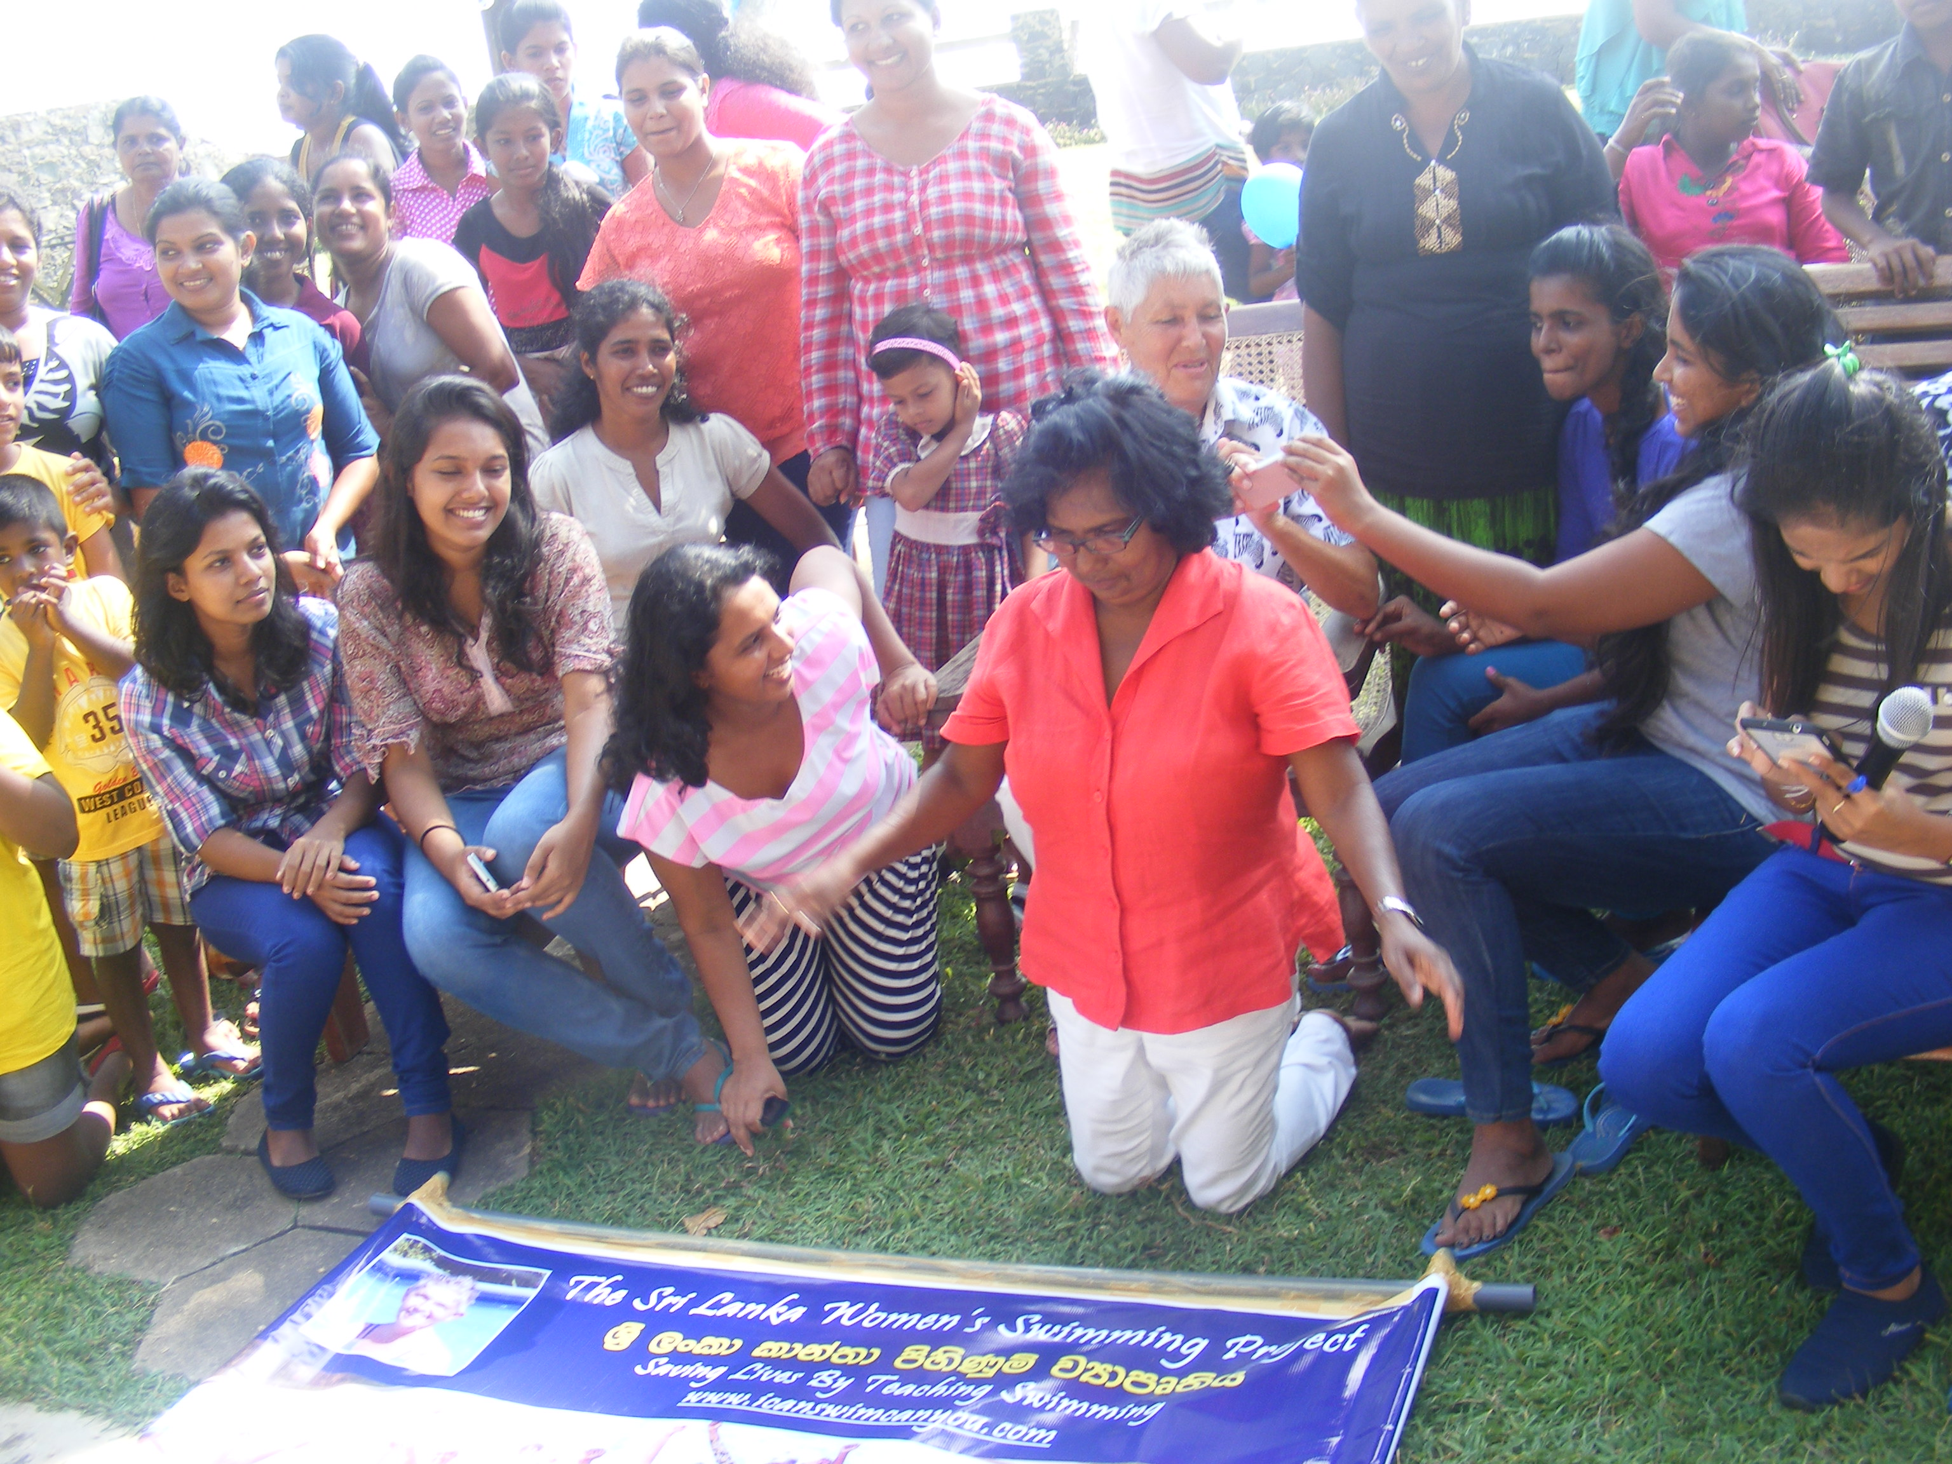
Image 5. Pauline Wijesinghe, in red shirt, kneeling, shares a joke with the Project’s STA teachers.

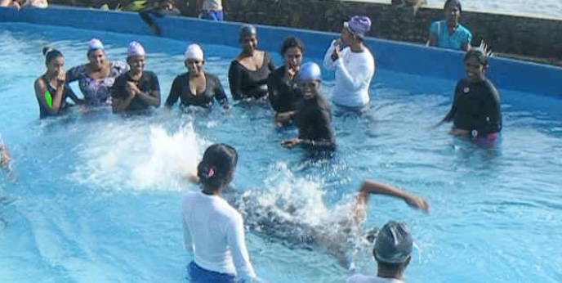
Image 6. To the delight and enthusiastic applause of her swimming teacher colleagues, Dinusha de Silva, the Project’s very first STA student swimming teacher and TI swimmer at the age of 14, is still the only swimmer present who can best the full, furious power of the Project’s ‘Fast Lane’ swim current generator. Dinusha is one of the Project’s key English translators and her entire family have been staunch supporters of the Project: Mom as administrator, Dad as driver, sister as swimming teacher and young brother as wannabe swimming teacher too.

